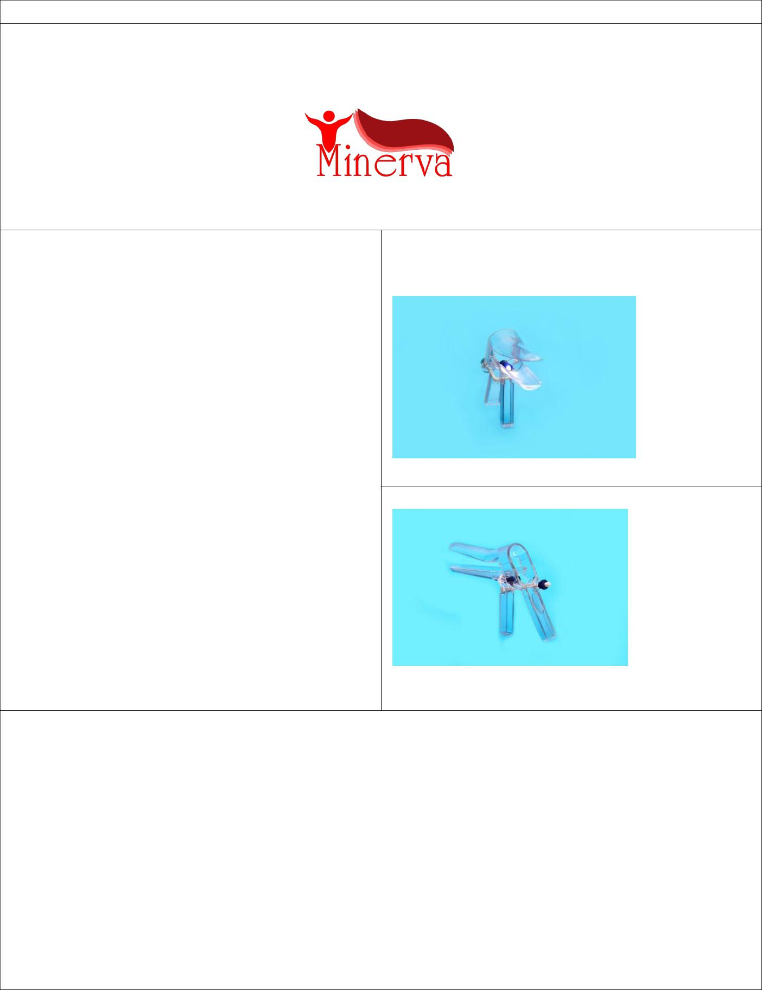

公司名字: Abzarsazan darmangar

品牌

产品说明:

一次性窥镜， 配备了抗痉挛和舒缓不适的直射灯

该产品最显著的特点是，直射灯，灯光颜色是白色, so that能够有效地增强阴道并能诊断出感染原因.

产品图片:

一次性窥镜， 配备了抗痉挛和舒缓不适的直射灯

-

1.一次性窥镜， 配备了抗痉挛和舒缓不适的直射灯. 没有额外的部分，防止擦伤和损坏阴道壁.

2-因为公司利用了一流和高质量的材料，产品高度透明.

3-该产品的结构可以减少由于平衡梯度引起的疼痛. 使用该装置时，可以将阴道壁分开.

.

4- 尺寸可以定制，适用于各种尺寸（小、中、大）.

5-该产品有9个版本，均已获得专利，其第一、第二版的生产线正在批量生产

中国供货价(美元):一次性窥镜装备直射灯: 28 美分

一次性窥镜没有装备直射灯:20 美分

最大订单量/最短供货时间(如: 1吨/月 或1000件/年等 ….):

**最小订单500 cartoon**

**送货时间: 2 周**

联系人: samira azimi

邮件: info@asd.co.ir

电话:+98 9189965429

地址**:** Abzar sazan darmangarco, Prof Hesabi Blvd, kermanshah industrial city, sanandajway, kermanshah, iran

公司联系方式:

网址:www.asd.co.ir

邮箱:info@asd.co.ir

电话:+98 83 34284137

传真:+98 83 34284138

地址:Abzar sazan darmangarco, Prof Hesabi Blvd, kermanshah industrial city, sanandajway, kermanshah, iran

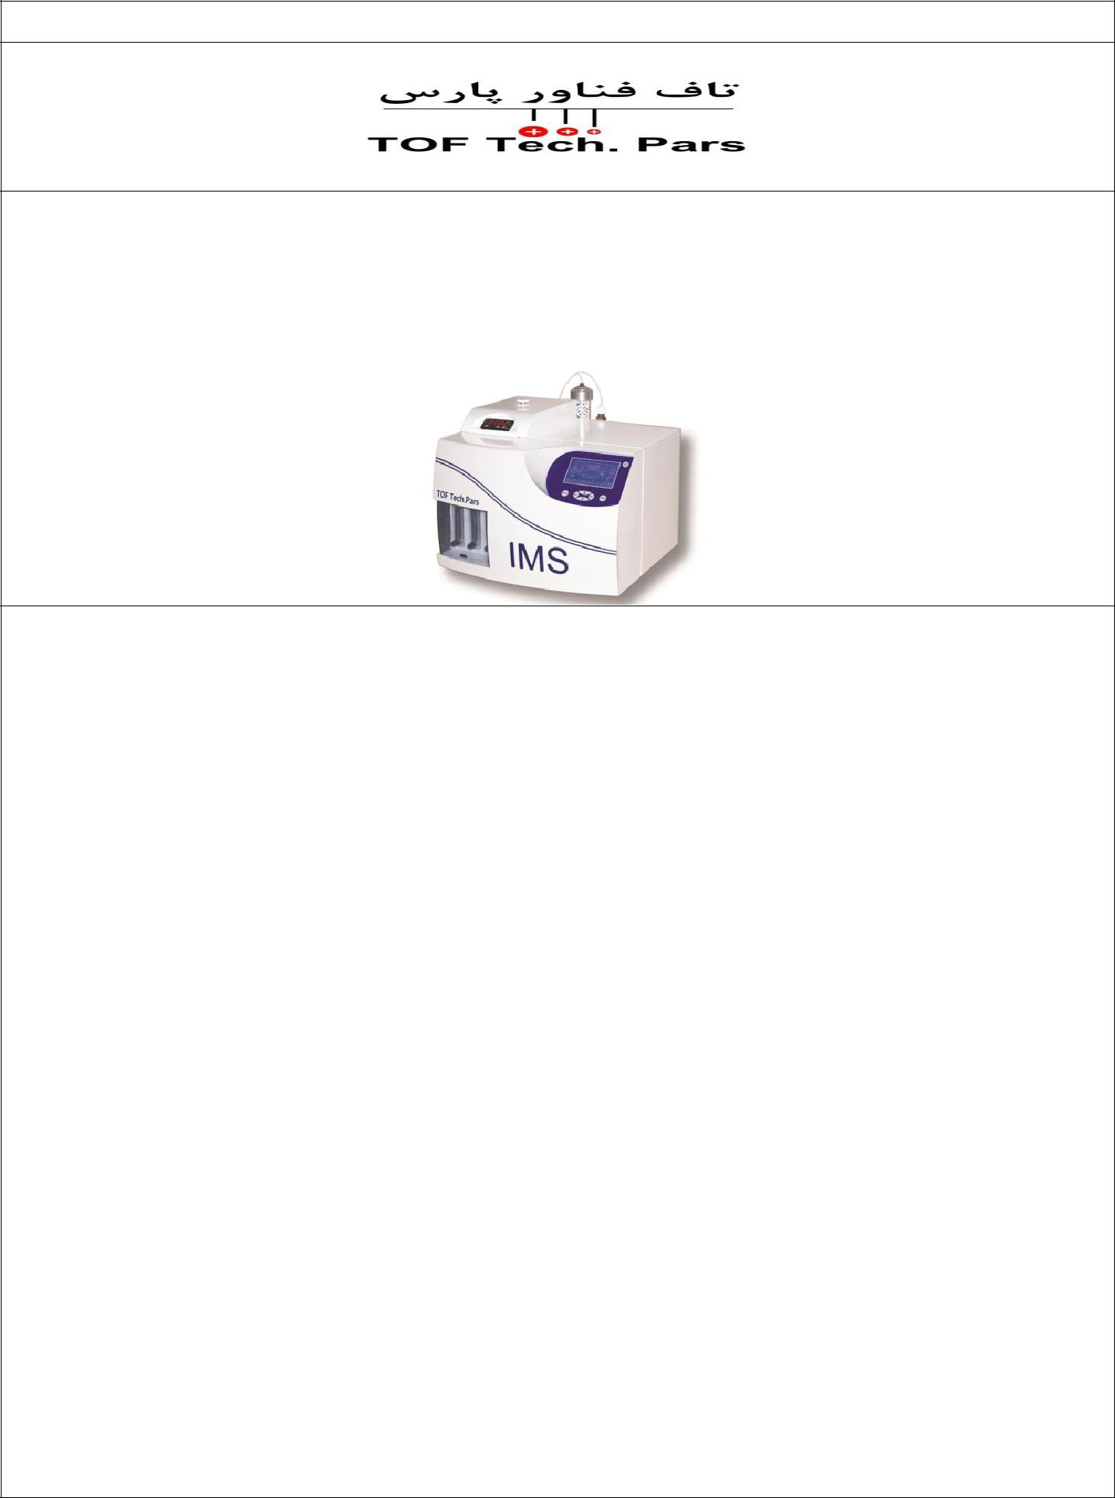

公司名字: **TOF Tech. Pars**

品牌

产品图片:

**研究级别离子迁移谱仪 (IMS)**

产品说明:

* 测量原理：离子迁移率
* 电离源：电晕放电
* 离子场电压范围: 0-500 V/cm
* 离子场温度范围: 25-200 oC
* 进样口温度范围: 25-260 oC
* 离子极性:阳极/阴极
* 检测方式: 电流
* 抽样形式: 固体、液体、气体
* 样品量: 公升
* 灵敏度: ppb
* 电子动态范围: ppb-ppm
* 分析时间:  5 Se
* 气体供应:零空气或者氮气
* 气流速度: 0 – 1000 mL/min
* 接口: USB 端口
* 电源: 220-250 V, 2 A
* 温度工作范围: 0-50 oC
* 湿度工作范围: 0-50%
* 系统: Windows

海关编码:

**9027.80.45.20**

标准和法律证书:

**纳米证书, CE**

售后和保修:

**1年保修，5年售后**

产品应用:

* **安保检测**
* 检测爆炸物、麻醉剂和化学气体
* **环境检测**
* 检测挥发性有机气体
* 检测水质 (如重矿物质)
* **呼气分析**
* **食品化学**
* 检测农药残留物
* 添加剂的检测和测定
* 检测肉类中抗生素的含量
* 检测黄曲霉菌和赭曲霉毒素
* **药剂学**
* 药物检测和分析
* 质量控制
* **分析化学**
  + 测定不同基质中微量的化学物质，例如: 血浆, 鼠尾草, 呼气, 口香糖, 鸡肉,药片, 糖浆和微生物环境中.
* **天然气和石化产品**
  + 乙烯中的氨气
  + 天然气中的硫化氢
* **学术与基础研究**

* 离子-分子反应的动力学和热力学
* 运输性能
* 移动和扩散系数
* 质子亲和力与电子亲和力
* 气相离子化学
* 量子计算的验证

生产力 (每月)**: 5**

售价 (出厂价):

中国供货价(美元): **29 k$**

最大订单量/最短供货时间 (如: 1吨/ 月 或者 1000 件/年或者 ….):

**50/年**

物料安全数据表或者技术数据表:

**没有危险和有毒成分**

联系人: Mahmoud Tabrizchi

邮箱: tabrizchi.mh@gmail.com

电话: +98 91331188003

地址**:**

**TOF Tech. Pars Co**.

地址：No. 119, Fanafarini 2, Isfahan Science &

Technology Town, Isfahan University of

Technology Blvd, Isfahan, IRAN,

邮编: 84156-83155

公司联系: **TOF Tech. Pars Co**

网址:: www.toftech.ir

邮箱:**:** toftech.ir@gmail.com

电话:: +98 913 0969 147

+98 31 33932250

传真:: +98 31 33932249

地址:

No. 119, Fanafarini 2, Isfahan Science & Technology Town, Isfahan University of Technology Blvd, Isfahan, IRAN,

邮编: 84156-83155

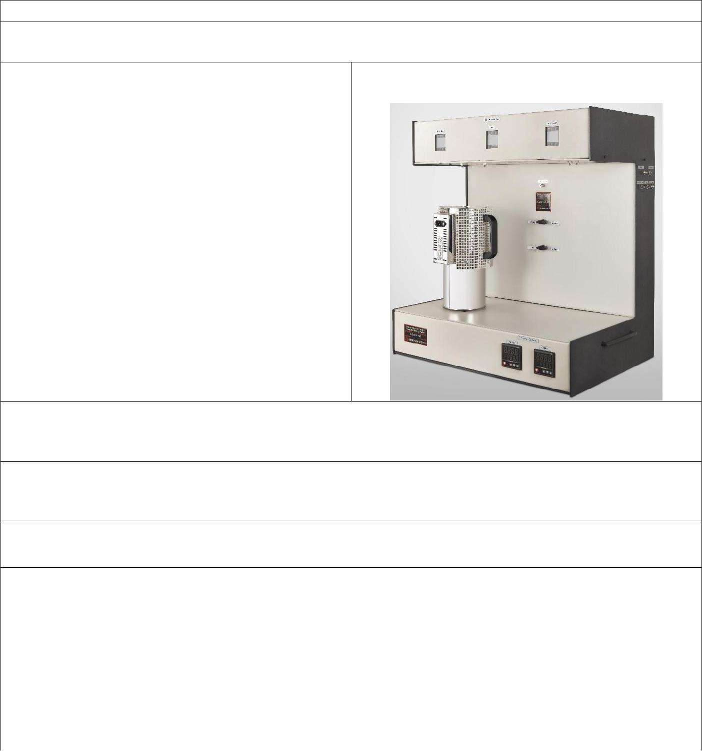

公司名字: Towse-e Hesgarsazan-e Asia (Sensiran)

品牌：GSCITS

|  |  |
| --- | --- |
| 产品规格: | 产品图片: |

这台仪器是由两台设备集成而成的: 数据测试以及气体传感器测试系统。.它用于半导体气体传感器的研究和开发 以及用于测试材料的催化性能.

生产力**: 4 套/年**

中国区供价(美元): **40000 $**

最大订单量/最短供货时间 (如: 1吨/ 月 或者 1000 件/年或者 ….) : **1 套/ 5 月**

物料安全数据表或者技术数据表:

|  |  |  |  |  |  |
| --- | --- | --- | --- | --- | --- |
| 联系人: | Ahamd Nemati | 公司联系信息: | | |  |
| 邮箱: | a.nemati@live.com | 网站: [www.Hesgarsazan.com](http://www.hesgarsazan.com/) | | |  |
|  |  |  |  |  |  |
| 电话: | +989113203951 | 邮箱: Sensiran@gmail.com | | |  |
| 地址**:** No. 153, 15th Noavari Ave. , Pardis Tech | | 电话: +982176250163 | | |  |
| Park, Tehran |  | 传真: +982176250163 | | |  |
|  | 地址: No. 153, 15th Noavari Ave. , Pardis Tech | | |  |
|  |  |  |
|  |  | Park, Tehran | | |  |

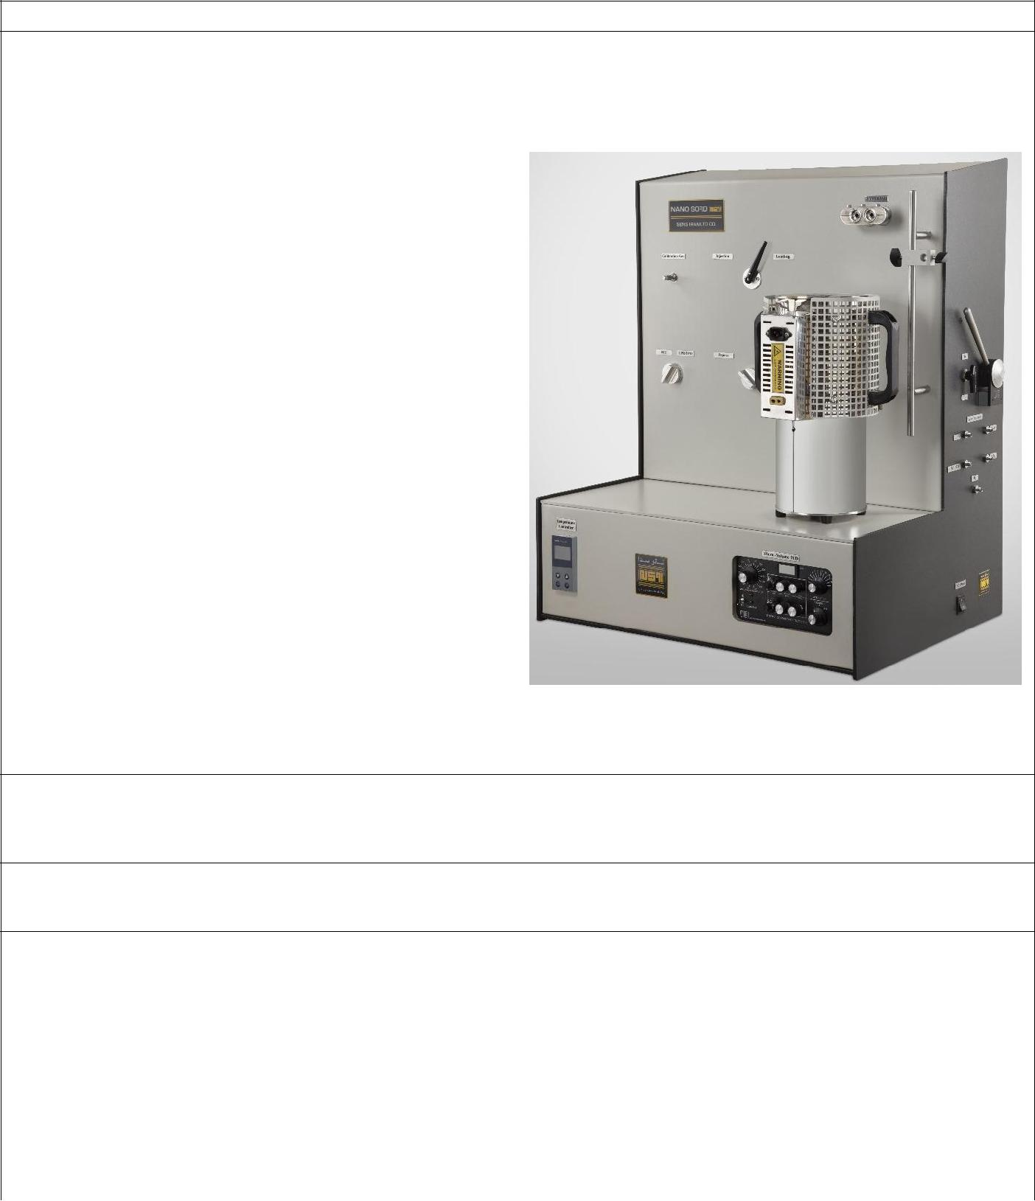

公司名字: Towse-e Hesgarsazan-e Asia (Sensiran)

NanoSORD

|  |  |
| --- | --- |
| 产品说明: | 产品图片: |
| 这是纳米结构材料中最广泛使用的设备之一，如 |  |
| 金属纳米粒子，金属氧化物和硫化物，碳纳米管，纳米纤维，纳米吸附剂等等。材料的属性是由设备决定的，包括比表面积，金属色散，吸附性能的纳米粒子，纳米金属氧化物的温度和机理。 |  |
|  |  |
|  |  |
| , |  |
|  |  |
|  |  |
|  |  |

生产力**: 4 件/年**

中国供货价(美元): **60000 $**

最大订单量/最短供货时间 (如: 1吨/ 月 或者 1000 件/年或者 ….):

**1 件 / 5 month**

物料安全数据表或者技术数据表:

|  |  |  |  |  |  |
| --- | --- | --- | --- | --- | --- |
| 联系人: | Ahamd Nemati | 公司信息: | | |  |
| 邮箱: | a.nemati@live.com | 网址: [www.Hesgarsazan.com](http://www.hesgarsazan.com/) | | |  |
|  |  |  |  |  |  |
| 电话: | +989113203951 | 邮箱: Sensiran@gmail.com | | |  |
| 地址**:** No. 153, 15th Noavari Ave. , Pardis Tech | | 电话: +982176250163 | | |  |
| Park, Tehran |  | 传真: +982176250163 | | |  |
|  | 地址: No. 153, 15th Noavari Ave. , Pardis Tech | | |  |
|  |  |  |
|  |  | Park, Tehran | | |  |

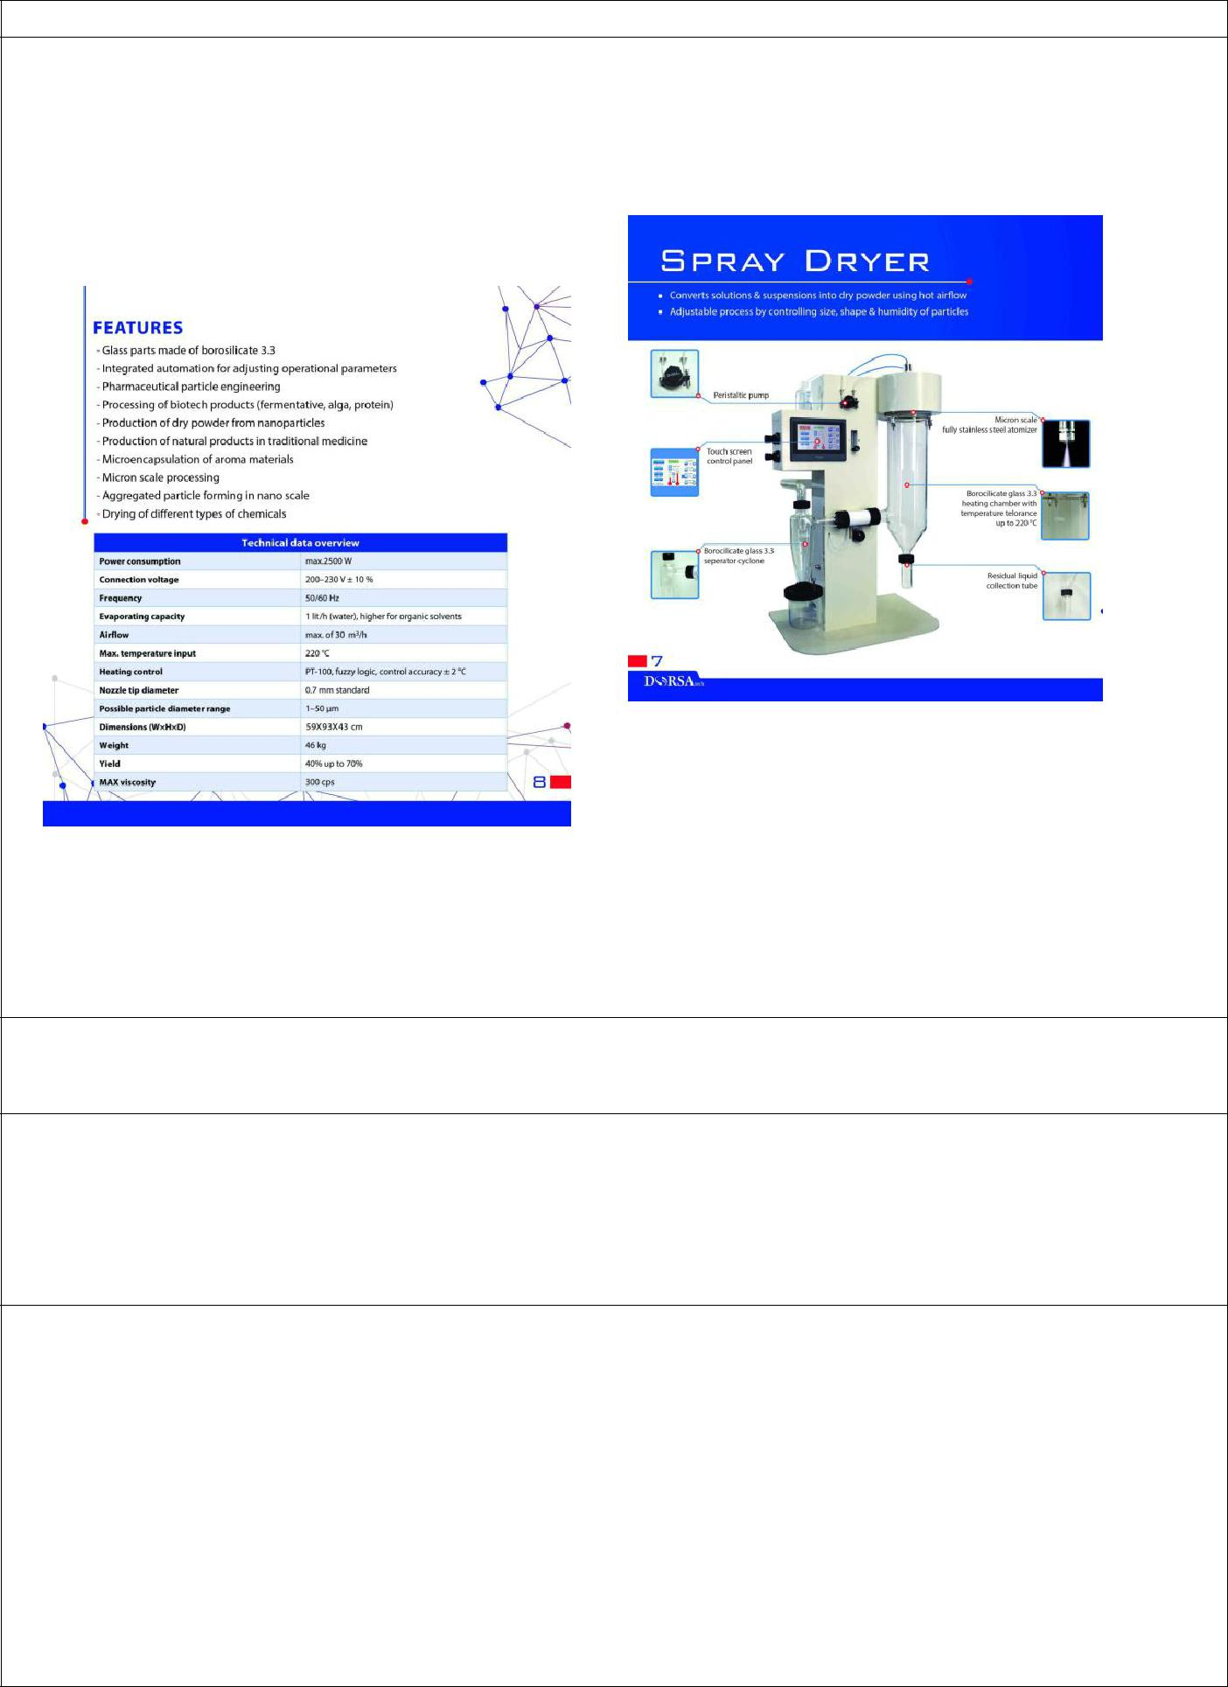

公司名字: Fanavari Darouei Dorsa Behsaz

品牌: Dorsa Tech

|  |  |
| --- | --- |
| 产品说明: | 产品图片: |
|  |  |

产品海关编码:

[84193900](https://www.eximpulse.com/import-product-spray-dryer-country-SWITZERLAND-hscode-84193900.htm)

标准和法律证书:

-

售后和保修:

一年保修，玻璃器皿除外

售后服务

五年保修，玻璃器皿除外

产品应用:

喷雾干燥和胶裹化药品

药物的活性成分，药物输送，疫苗，可吸入药物，隐藏气味

喷雾干燥和封装食品

添加剂的封装，控释，营养食品，功能食品，风味添加剂，维生素，蛋白质，益生菌，浓缩果汁，奶粉

喷雾干燥和封装类

浓缩添加剂、香料、维生素、蛋白质、益生菌类



干燥和封装

广泛用于学术教育

生产力 (每月):

20

售价 (出厂价): 13300 $

中国区供货价(美元):

最大订单量: 1 set

最短供货时间: 45 days

物料安全数据表或者技术数据表:

|  |  |
| --- | --- |
| 联系人: mojtaba vatanara | 公司联系方式: |
| 邮箱:mojtaba.vatanara@gmail.com | 网站:www.dorsatech.ir |
| 电话:+989123835346 | 邮箱:info@dorsatech.ir |
| 地址**:** Alborz Science and Technology Park | 电话 :+982632309073 |
|  | 传真:+982632309063 |
|  | 地址: Alborz Science and Technology Park |
|  |  |

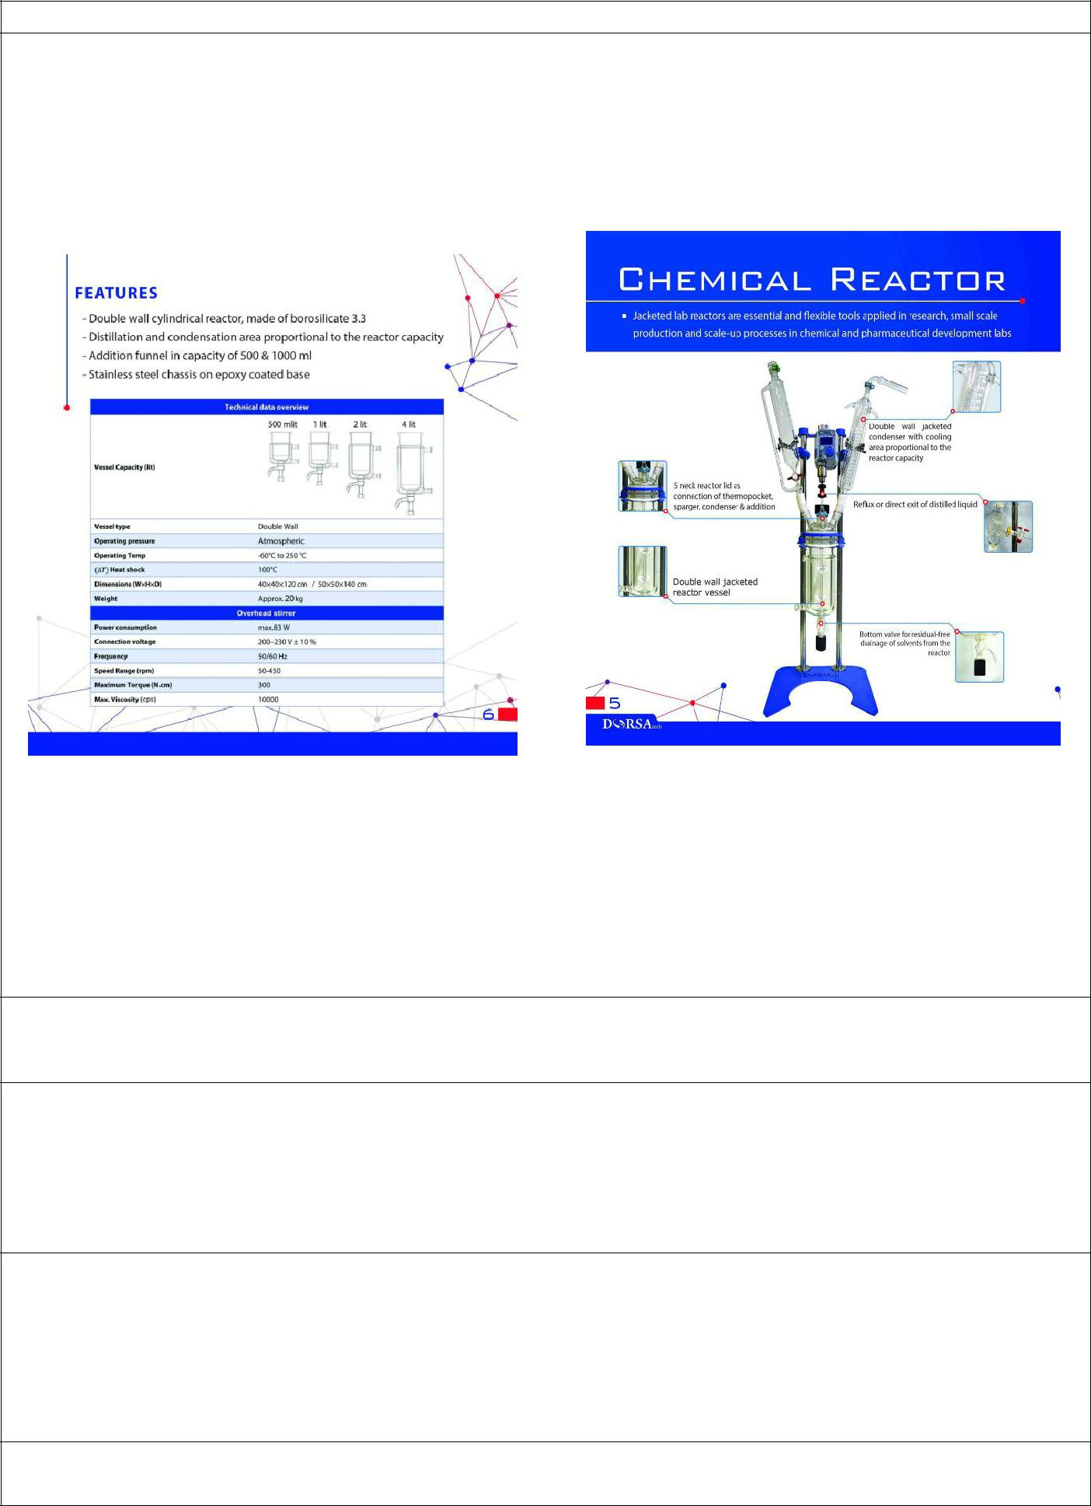

Company name: Fanavari Darouei Dorsa Behsaz

Brand: Dorsa Tech

|  |  |
| --- | --- |
| Product Specifications: | Product photo: |
|  |  |

HS code of product:

8419899000

Standards and legally certificates:

-

After sale services/ Guarantee:

After sale services/ Guarantee:

[One Year Warranty](https://www.google.com/url?sa=t&rct=j&q=&esrc=s&source=web&cd=14&cad=rja&uact=8&ved=0ahUKEwi-3JresYnWAhWJw1QKHciSBCY4ChAWCDkwAw&url=https%3A%2F%2Fsupport.juulvapor.com%2Fhome%2Flearn%2Fwarranty&usg=AFQjCNFJ9WhHReD1BU726b7QbAWvXgXsmQ) except glassware

After sale services:

[5 Year Warranty](https://www.google.com/url?sa=t&rct=j&q=&esrc=s&source=web&cd=14&cad=rja&uact=8&ved=0ahUKEwi-3JresYnWAhWJw1QKHciSBCY4ChAWCDkwAw&url=https%3A%2F%2Fsupport.juulvapor.com%2Fhome%2Flearn%2Fwarranty&usg=AFQjCNFJ9WhHReD1BU726b7QbAWvXgXsmQ) except glassware

Product’s Application:

chemical synthesis, process development, workup, filtration, purification, evaporation, stirring, dissolving, mixing, and extracting operations across a host of scientific disciplines

Production capacity (per month):

20



Sales’ Price (EXW): 3400 $

Offer price in China($):

Maximum order: 1 set

Minimum delivery time:45 days

MSDS or Technical data sheet:

|  |  |
| --- | --- |
| Company contact: | Company contact: |
| Website:www.dorsatech.ir | Website:www.dorsatech.ir |
| Email:info@dorsatech.ir | Email:info@dorsatech.ir |
| Tell :+982632309073 | Tell :+982632309073 |
| Fax:+982632309063 | Fax:+982632309063 |
| Address: Alborz Science and Technology Park | Address: Alborz Science and Technology Park |



Company name: Fanavari Darouei Dorsa Behsaz

Brand: Dorsa Tech

|  |  |
| --- | --- |
| Product Specifications: | Product photo: |
|  |  |

HS code of product:

8419899000

Standards and legally certificates:

-

After sale services/ Guarantee:

After sale services/ Guarantee:

[One Year Warranty](https://www.google.com/url?sa=t&rct=j&q=&esrc=s&source=web&cd=14&cad=rja&uact=8&ved=0ahUKEwi-3JresYnWAhWJw1QKHciSBCY4ChAWCDkwAw&url=https%3A%2F%2Fsupport.juulvapor.com%2Fhome%2Flearn%2Fwarranty&usg=AFQjCNFJ9WhHReD1BU726b7QbAWvXgXsmQ) except glassware

After sale services:

[5 Year Warranty](https://www.google.com/url?sa=t&rct=j&q=&esrc=s&source=web&cd=14&cad=rja&uact=8&ved=0ahUKEwi-3JresYnWAhWJw1QKHciSBCY4ChAWCDkwAw&url=https%3A%2F%2Fsupport.juulvapor.com%2Fhome%2Flearn%2Fwarranty&usg=AFQjCNFJ9WhHReD1BU726b7QbAWvXgXsmQ) except glassware

Product’s Application:

chemical synthesis, process development, workup, filtration, purification, evaporation, stirring, dissolving, mixing, and extracting operations across a host of scientific disciplines

Production capacity (per month):

20



Sales’ Price (EXW): 5200 $

Offer price in China($):

Maximum order: 1 set

Minimum delivery time:45 days

MSDS or Technical data sheet:

|  |  |
| --- | --- |
| Company contact: | Company contact: |
| Website:www.dorsatech.ir | Website:www.dorsatech.ir |
| Email:info@dorsatech.ir | Email:info@dorsatech.ir |
| Tell :+982632309073 | Tell :+982632309073 |
| Fax:+982632309063 | Fax:+982632309063 |
| Address: Alborz Science and Technology Park | Address: Alborz Science and Technology Park |

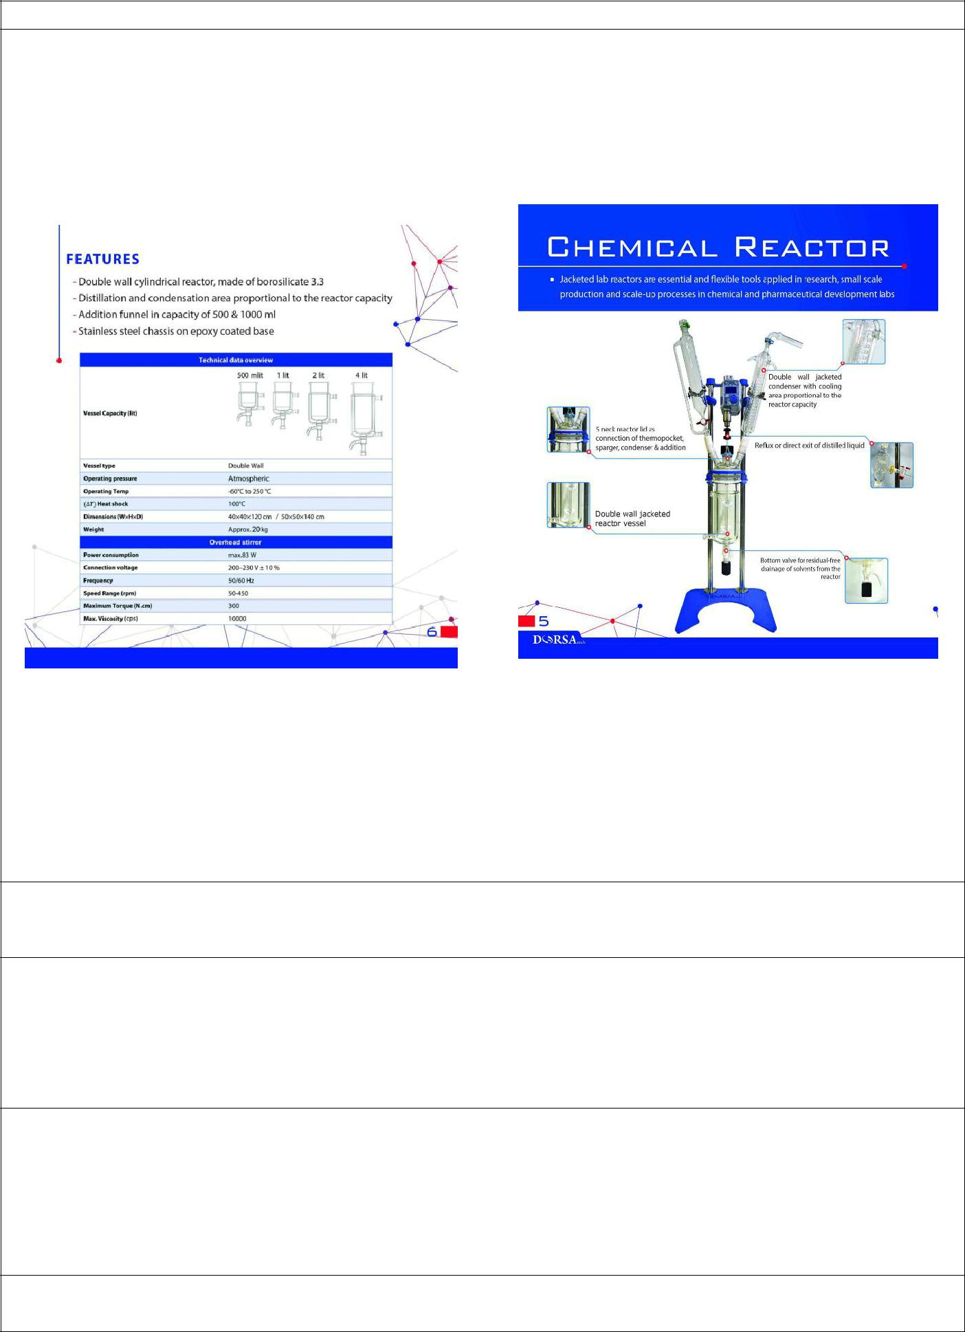

Company name: Fanavari Darouei Dorsa Behsaz

Brand: Dorsa Tech

|  |  |
| --- | --- |
| Product Specifications: | Product photo: |
|  |  |

HS code of product:

8419899000

Standards and legally certificates:

-

After sale services/ Guarantee:

After sale services/ Guarantee:

[One Year Warranty](https://www.google.com/url?sa=t&rct=j&q=&esrc=s&source=web&cd=14&cad=rja&uact=8&ved=0ahUKEwi-3JresYnWAhWJw1QKHciSBCY4ChAWCDkwAw&url=https%3A%2F%2Fsupport.juulvapor.com%2Fhome%2Flearn%2Fwarranty&usg=AFQjCNFJ9WhHReD1BU726b7QbAWvXgXsmQ) except glassware

After sale services:

[5 Year Warranty](https://www.google.com/url?sa=t&rct=j&q=&esrc=s&source=web&cd=14&cad=rja&uact=8&ved=0ahUKEwi-3JresYnWAhWJw1QKHciSBCY4ChAWCDkwAw&url=https%3A%2F%2Fsupport.juulvapor.com%2Fhome%2Flearn%2Fwarranty&usg=AFQjCNFJ9WhHReD1BU726b7QbAWvXgXsmQ) except glassware

Product’s Application:

chemical synthesis, process development, workup, filtration, purification, evaporation, stirring, dissolving, mixing, and extracting operations across a host of scientific disciplines

Production capacity (per month):

20



Sales’ Price (EXW): 4500 $

Offer price in China($):

Maximum order: 1 set

Minimum delivery time:45 days

MSDS or Technical data sheet:

|  |  |
| --- | --- |
| Company contact: | Company contact: |
| Website:www.dorsatech.ir | Website:www.dorsatech.ir |
| Email:info@dorsatech.ir | Email:info@dorsatech.ir |
| Tell :+982632309073 | Tell :+982632309073 |
| Fax:+982632309063 | Fax:+982632309063 |
| Address: Alborz Science and Technology Park | Address: Alborz Science and Technology Park |



Company name: Fanavari Darouei Dorsa Behsaz

Brand: Dorsa Tech

|  |  |
| --- | --- |
| Product Specifications: | Product photo: |
|  |  |

HS code of product:

8419899000

Standards and legally certificates:

-

After sale services/ Guarantee:

After sale services/ Guarantee:

[One Year Warranty](https://www.google.com/url?sa=t&rct=j&q=&esrc=s&source=web&cd=14&cad=rja&uact=8&ved=0ahUKEwi-3JresYnWAhWJw1QKHciSBCY4ChAWCDkwAw&url=https%3A%2F%2Fsupport.juulvapor.com%2Fhome%2Flearn%2Fwarranty&usg=AFQjCNFJ9WhHReD1BU726b7QbAWvXgXsmQ) except glassware

After sale services:

[5 Year Warranty](https://www.google.com/url?sa=t&rct=j&q=&esrc=s&source=web&cd=14&cad=rja&uact=8&ved=0ahUKEwi-3JresYnWAhWJw1QKHciSBCY4ChAWCDkwAw&url=https%3A%2F%2Fsupport.juulvapor.com%2Fhome%2Flearn%2Fwarranty&usg=AFQjCNFJ9WhHReD1BU726b7QbAWvXgXsmQ) except glassware

Product’s Application:

chemical synthesis, process development, workup, filtration, purification, evaporation, stirring, dissolving, mixing, and extracting operations across a host of scientific disciplines

Production capacity (per month):

20



Sales’ Price (EXW): 4000 $

Offer price in China($):

Maximum order: 1 set

Minimum delivery time:45 days

MSDS or Technical data sheet:

|  |  |
| --- | --- |
| Company contact: | Company contact: |
| Website:www.dorsatech.ir | Website:www.dorsatech.ir |
| Email:info@dorsatech.ir | Email:info@dorsatech.ir |
| Tell :+982632309073 | Tell :+982632309073 |
| Fax:+982632309063 | Fax:+982632309063 |
| Address: Alborz Science and Technology Park | Address: Alborz Science and Technology Park |

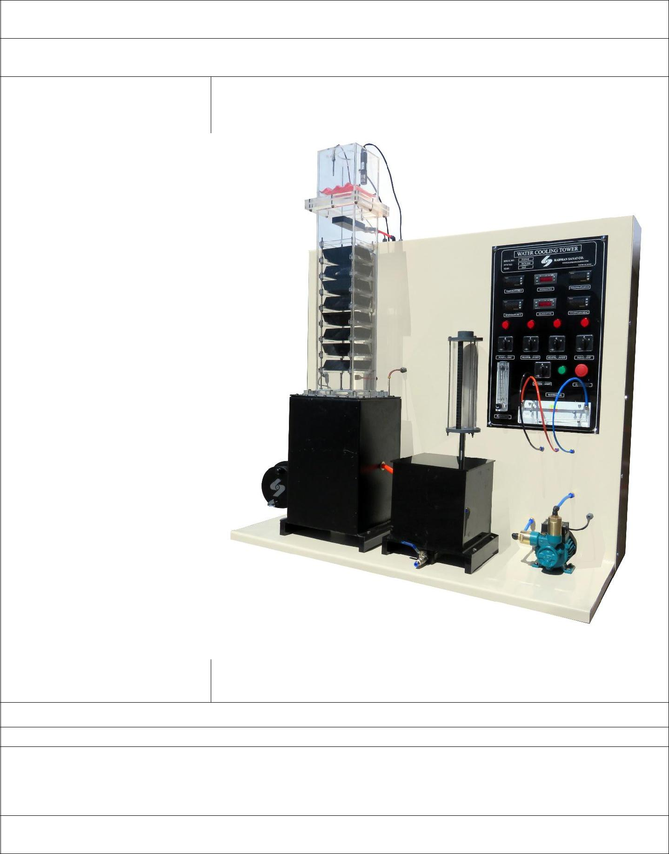

Company name: Radman Sanat

Brand: Radman Sanat

|  |  |
| --- | --- |
| Product Specifications: | Product photo: |

Fan for air supply

0.5 KW and 1KW Heater Temperature Transmitters Humidity Transmitters Feeding Tank

Stainless Steel Tower Tank Plexy Glass Makeup Tank Water Rotameter Manometer

Box for electronic indicators and instruments for system control

production capacity**:**

offer price in China($): 3990

Maximum order/Minimum delivery time (EX: one ton/one month or 1000/year or ….):

Maximum Order per Month/ 20 units

MSDS OR Technical data sheet:

|  |  |
| --- | --- |
| contact person: Rasheed | Company contact: |
| Kamyab | Website: www.radmansanatco.com |
| Email: | Email: sales@radmansanatco.com |
| kamyab.r@radmansanatco.co | Tell : +98 71 36359304 |
| m | Fax: +98 71 36243424 |
| Tell: +98 71 36243424 | Address: Fars Science & Technology Park, Shiraz-Iran |
| Address**:** Fars Science & |  |
| Technology Park, Shiraz-Iran |  |
|  |  |

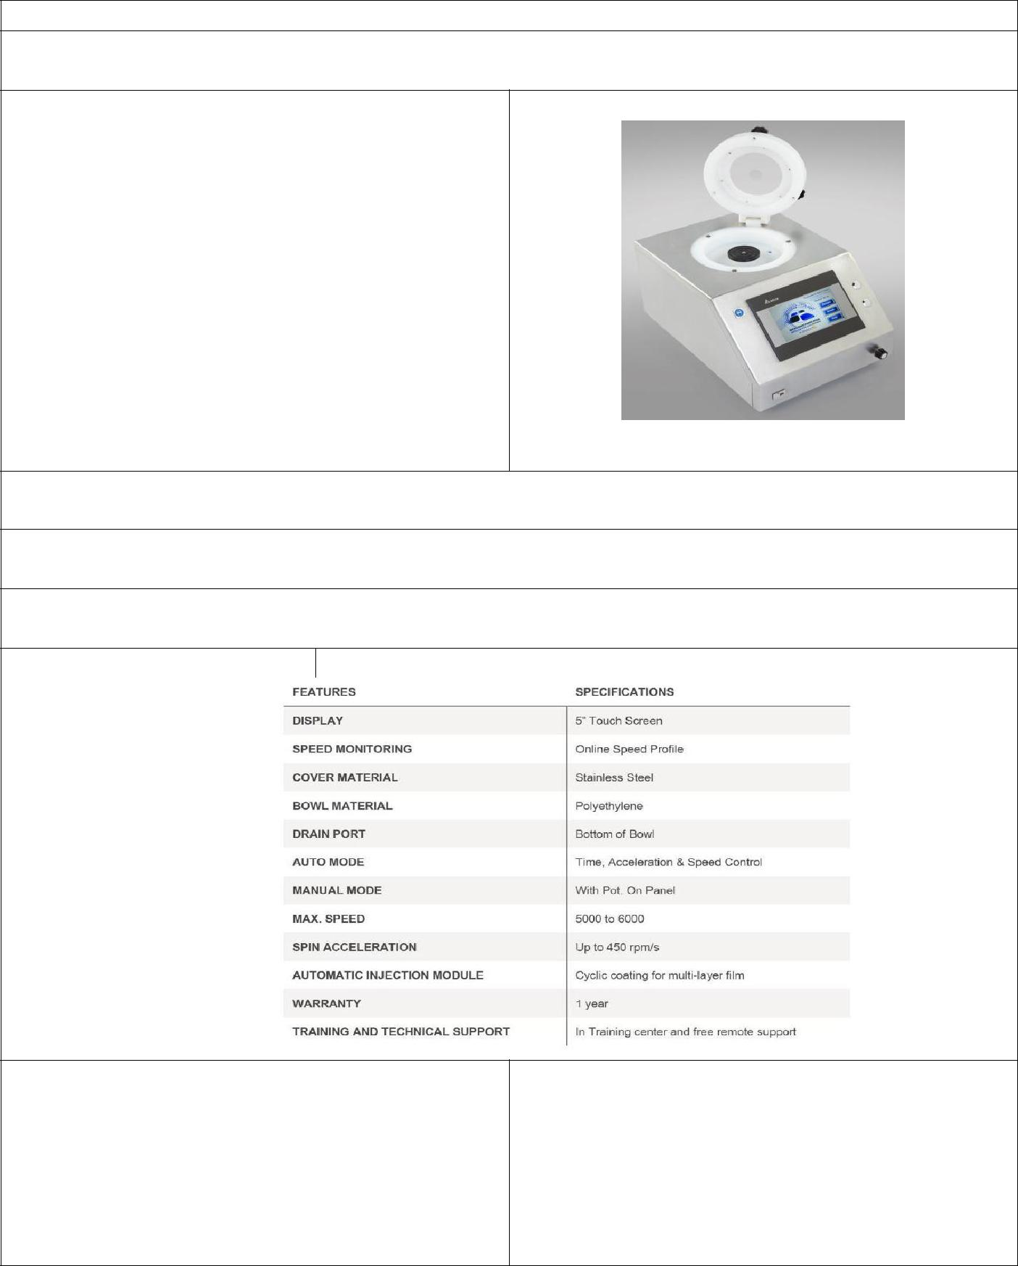

Company name: Satalab Co.

Brand

Professional Spin Coater

|  |  |
| --- | --- |
| Product Specifications: | Product photo: |

* 5 inch touch screen
* On Screen speed profile display
* Stainless steel Body
* Polypropylene Bowl
* Custom design chuck
* Time, Acceleration & Speed control
* Manual control option
* 5000-6000 rpm speed
* Up to 450 rpm/sec acceleration
* 1 year warranty
* Remote technical support

production capacity: 40 pcs/Year

offer price in China($):

3500$ for 1-5 pcs – 3000$ for more than 5pcs in a batch

Maximum order/Minimum delivery time (EX: one ton/one month or 1000/year or ….):

4 pcs/Month – 2 month minimum delivery time

MSDS OR Technical data sheet:

contact person: Amir Behtash

Email: amir.behtash@gmail.com

Tell: +98 912 8182046

Address**:** Block 16, Saman ST, 23rd ST, Chahardangeh industrial Town, Tehran, Iran

Company contact: Amir Behtash

Website: www.satalab.co

Email: samanetajhiz@gmail.cm

Tell : +98 21 55280305

Fax: +98 21 55280313

Address: Block 16, Saman ST, 23rd ST, Chahardangeh industrial Town, Tehran, Iran

Brand

**Fater Electronic**

|  |  |  |  |  |
| --- | --- | --- | --- | --- |
|  |  | **XF620 TC** | Product photo: |  |
| Product Specifications: | |  |  |
| • 200 Liter & 400 Liter interior Capacity | | |  |  |
| • | 20- C to - 70 °C | ± 1.0 |  |  |
| • Microprocessor with touchscreen input and | | |  |  |
|  | display |  |  |  |
| • Lockable door (Optional PIN requirement built | | |  |  |
|  | in |  |  |  |
| • Fully adjustable Warm and Cold Alarms | | |  |  |
| • Event Logs on All time temp, All alarms, door | | |  |  |
|  | openings |  |  |  |
| • Battery Back-up 12 hour control battery back- | | |  |  |
|  | up for touchscreen | |  |  |
| • Pull-Down from Ambien 7 hours on 70- ºC Set | | |  |  |
|  | point at ambient 25ºC ± 2ºC, | |  |  |
| • | when Empty Cabinet | |  |  |
| • 2 stainless steel, fixed position (removable) | | |  |  |
| • interior housing Stainless Steel | | |  |  |

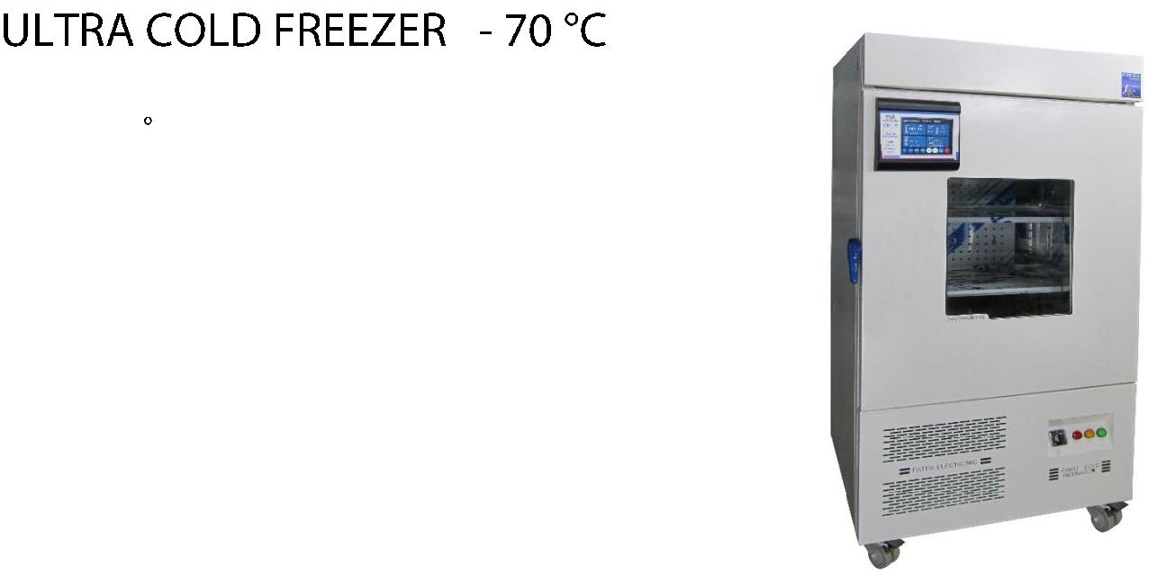

production capacity**:**

offer price in China ($):

**US$ 5450**

Maximum order/Minimum delivery time (EX: one ton/one month or 1000/year or ….):

|  |  |  |  |  |  |  |
| --- | --- | --- | --- | --- | --- | --- |
|  | **30 pcs** | **/ 45 days** | |  |  |  |
|  | MSDS OR Technical data sheet: | | |  |  |  |
|  |  |  |  |  |  |  |
|  |  |  | XF620 |  | XF640 |  |
|  | Capacity | | 200L |  | 400L |  |
|  | Temperature | | -70 C to 20- C ambient, adjustable |  | -70 C to 20- C ambient, adjustable to |  |
|  | Range | C | to 0.1 C increments |  | 0.1 C increments |  |
|  | Electrical | | 50/220 V/Hz |  | 50/220 V/Hz |  |
|  | Connection | |  |  |  |  |
|  | Power |  | 800 watts 3 amps |  | 1200 watts 5.5 amps |  |
|  | (Current) | |  |  |  |  |
|  | Electric Supply | | 15 amp or greater grounded circuit |  | 15 amp or greater grounded circuit |  |
|  | Rating |  |  |  |  |  |
|  | Controller Type | | Microprocessor & touch LCD |  | Microprocessor & touch LCD |  |
|  |  | |  |  |  |  |
|  | contact person: | | Ali Arghavan | Company contact: | |  |
|  | Email: head@fater.ir | | | Website: www.fater.ir (www.fater- | |  |
|  | Tell: +98- 9121272405 | | | electronic.com) | |  |
|  | Address**: Tehran-Iran** | | | Email: head@fater.ir | |  |
|  |  |  |  | Tell: +98 -21 88552340-42 | |  |
|  |  |  |  | Fax: +98 – 21 88552305 | |  |
|  |  |  |  | Address: No.14, 18th St., Vozara Ave., | |  |
|  |  |  |  | Tehran-Iran | |  |

